* Step 1: Log in to <https://www.shopify.com/partners>
* Step 2: Log in to the store

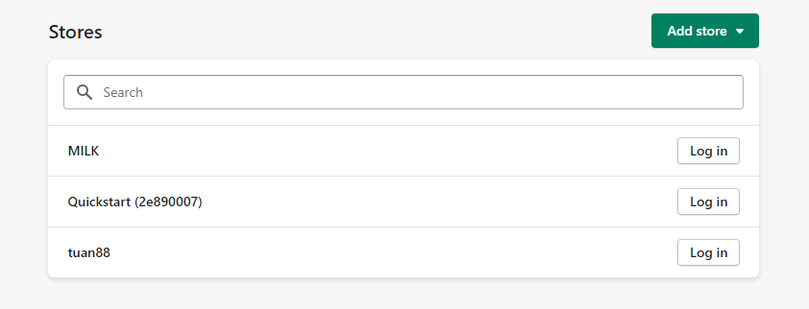

* Step 3: Select online store

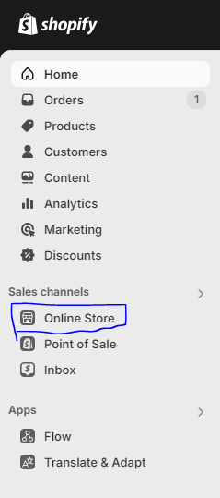

* Step 4: At current theme, select edit code

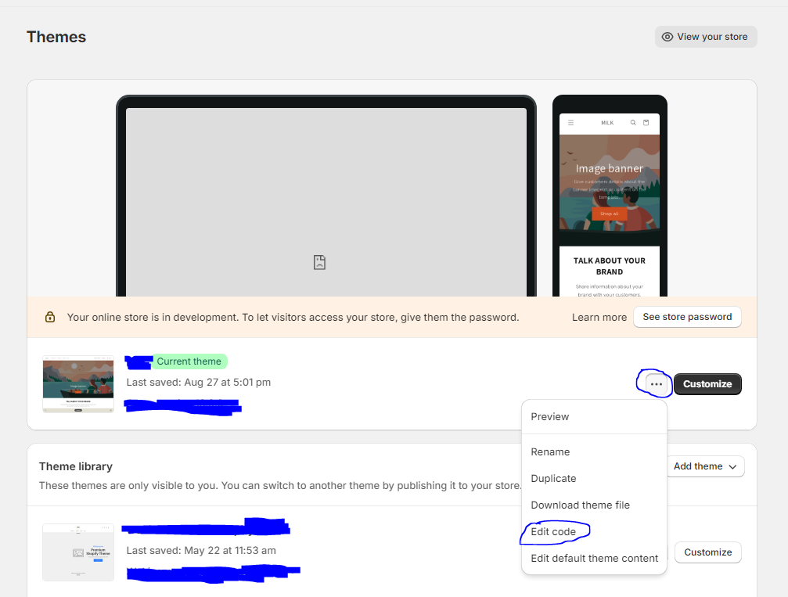

* Step 5:

+ In the templates folder, select the product.json file

+ In sections -> main -> type, we will see the value of type, in this example it is "main-product". This is the name of the template file used to display product details, the file name will be "main-product.liquid"

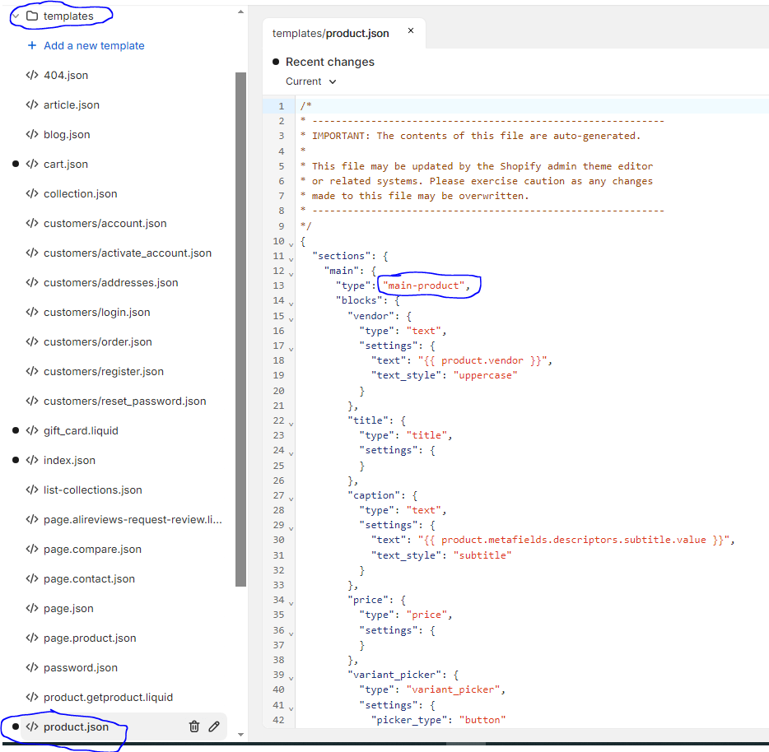

* Step 6:

+ In the sections folder, select the “main-product.liquid” file

+ Press Ctrl + F, search for keyword "product.title", then add the content “<div product-id="{{ product.id }}" class="nb-review-badge"></div>” right after the heading tag like the example below

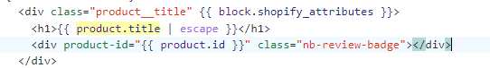

+ If searching for the keyword "product.title" has many results, you can add any keyword right after each result, then save the file, return to the website, go to the details of a product and Check to see if any newly added characters are displayed correctly in the desired position. If yes, then that position is where you need to place the “<div product-id="{{ product.id }}" class="nb-review-badge"></div>” tag

**Add content “TEST 123”**

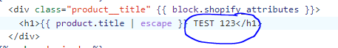

**CHECK**

